Repeated Measures ANOVA Report
Page/Date/Time 1 8/1/2014 1:24:02 PM
Database C:\Users\emariano\Desktop\FAER Analysis\FAER survey data.S0
Response TOT_S

Expected Mean Squares Section
Source Term Denominator Expected
Term DF Fixed? Term Mean Square
A: QTR 4 Yes B(A) S+sB+bsA
B(A): SUBJ 27 No S(AB) S+sB
S(AB) 128 No S
Note: Expected Mean Squares are for the balanced cell-frequency case.

Analysis of Variance Table
Source Sum of Mean Prob Power
Term DF Squares Square F-Ratio Level (Alpha=0.05)
A: QTR 4 265.2125 66.30312 0.07 0.989374 0.062785
B(A): SUBJ 27 24060 891.111 12.14 0.000000*
S 128 9396.4 73.40938
Total (Adjusted) 159 33721.61
Total 160
* Term significant at alpha = 0.05

Probability Levels for F-Tests with Geisser-Greenhouse Adjustments
Lower Geisser Huynh
Bound Greenhouse Feldt
Regular Epsilon Epsilon Epsilon
Source Prob Prob Prob Prob
Term DF F-Ratio Level Level Level Level
A: QTR 4 0.07 0.989374
B(A): SUBJ 27 12.14 0.000000*
S 128

Power Values for F-Tests with Geisser-Greenhouse Adjustments Section
Lower Geisser Huynh
Bound Greenhouse Feldt
Regular Epsilon Epsilon Epsilon
Source Power Power Power Power
Term DF F-Ratio (Alpha=0.05) (Alpha=0.05) (Alpha=0.05) (Alpha=0.05)
A: QTR 4 0.07 0.062785
B(A): SUBJ 27 12.14 1.000000
S 128

Note: Mauchly's statistic actually tests the more restrictive assumption that the pooled covariance matrix
has compound symmetry.

Repeated Measures ANOVA Report
Page/Date/Time 2 8/1/2014 1:24:02 PM
Database C:\Users\emariano\Desktop\FAER Analysis\FAER survey data.S0
Response TOT_S

Means and Standard Error Section
Standard
Term Count Mean Error
All 160 13.11563
A: QTR
0 32 11.75 5.277047
1 32 12.17188 5.277047
2 32 12.84375 5.277047
3 32 13.375 5.277047
4 32 15.4375 5.277047

Plots Section

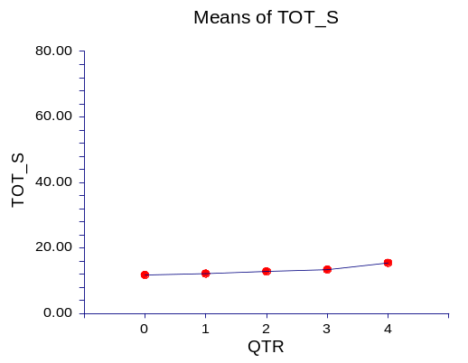

Tukey-Kramer Multiple-Comparison Test

Response: TOT_S
Term A: QTR

Alpha=0.050 Error Term=B(A) DF=27 MSE=891.111 Critical Value=4.1305

Different From
Group Count Mean Groups
0 32 11.75
1 32 12.17188
2 32 12.84375
3 32 13.375
4 32 15.4375

Notes:
This report provides multiple comparison tests for all pairwise differences between
the means.

Repeated Measures ANOVA Report
Page/Date/Time 3 8/1/2014 1:24:03 PM
Database C:\Users\emariano\Desktop\FAER Analysis\FAER survey data.S0
Response TOT_C

Expected Mean Squares Section
Source Term Denominator Expected
Term DF Fixed? Term Mean Square
A: QTR 4 Yes B(A) S+sB+bsA
B(A): SUBJ 27 No S(AB) S+sB
S(AB) 128 No S
Note: Expected Mean Squares are for the balanced cell-frequency case.

Analysis of Variance Table
Source Sum of Mean Prob Power
Term DF Squares Square F-Ratio Level (Alpha=0.05)
A: QTR 4 24.6625 6.165625 0.17 0.949628 0.081273
B(A): SUBJ 27 954.5812 35.35486 12.00 0.000000*
S 128 377.2 2.946875
Total (Adjusted) 159 1356.444
Total 160
* Term significant at alpha = 0.05

Probability Levels for F-Tests with Geisser-Greenhouse Adjustments
Lower Geisser Huynh
Bound Greenhouse Feldt
Regular Epsilon Epsilon Epsilon
Source Prob Prob Prob Prob
Term DF F-Ratio Level Level Level Level
A: QTR 4 0.17 0.949628
B(A): SUBJ 27 12.00 0.000000*
S 128

Power Values for F-Tests with Geisser-Greenhouse Adjustments Section
Lower Geisser Huynh
Bound Greenhouse Feldt
Regular Epsilon Epsilon Epsilon
Source Power Power Power Power
Term DF F-Ratio (Alpha=0.05) (Alpha=0.05) (Alpha=0.05) (Alpha=0.05)
A: QTR 4 0.17 0.081273
B(A): SUBJ 27 12.00 1.000000
S 128

Note: Mauchly's statistic actually tests the more restrictive assumption that the pooled covariance matrix
has compound symmetry.

Repeated Measures ANOVA Report
Page/Date/Time 4 8/1/2014 1:24:03 PM
Database C:\Users\emariano\Desktop\FAER Analysis\FAER survey data.S0
Response TOT_C

Means and Standard Error Section
Standard
Term Count Mean Error
All 160 1.23125
A: QTR
0 32 0.5 1.051113
1 32 1.4375 1.051113
2 32 1.46875 1.051113
3 32 1.15625 1.051113
4 32 1.59375 1.051113

Plots Section

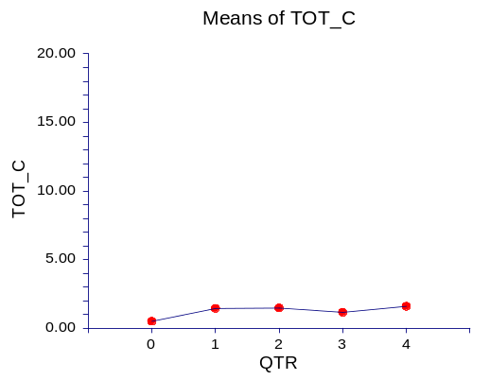

Tukey-Kramer Multiple-Comparison Test

Response: TOT_C
Term A: QTR

Alpha=0.050 Error Term=B(A) DF=27 MSE=35.35486 Critical Value=4.1305

Different From
Group Count Mean Groups
0 32 0.5
3 32 1.15625
1 32 1.4375
2 32 1.46875
4 32 1.59375

Notes:
This report provides multiple comparison tests for all pairwise differences between
the means.

Repeated Measures ANOVA Report
Page/Date/Time 5 8/1/2014 1:24:03 PM
Database C:\Users\emariano\Desktop\FAER Analysis\FAER survey data.S0
Response Avg_block_success_rate____

Expected Mean Squares Section
Source Term Denominator Expected
Term DF Fixed? Term Mean Square
A: QTR 4 Yes B(A) S+sB+bsA
B(A): SUBJ 27 No S(AB) S+sB
S(AB) 124 No S
Note: Expected Mean Squares are for the balanced cell-frequency case.

Analysis of Variance Table
Source Sum of Mean Prob Power
Term DF Squares Square F-Ratio Level (Alpha=0.05)
A: QTR 4 12770.6 3192.649 0.85 0.503967 0.235479
B(A): SUBJ 27 100969 3739.593 5.95 0.000000*
S 124 77982.8 628.8936
Total (Adjusted) 155 191722.4
Total 156
* Term significant at alpha = 0.05

Probability Levels for F-Tests with Geisser-Greenhouse Adjustments
Lower Geisser Huynh
Bound Greenhouse Feldt
Regular Epsilon Epsilon Epsilon
Source Prob Prob Prob Prob
Term DF F-Ratio Level Level Level Level
A: QTR 4 0.85 0.503967
B(A): SUBJ 27 5.95 0.000000*
S 124

Power Values for F-Tests with Geisser-Greenhouse Adjustments Section
Lower Geisser Huynh
Bound Greenhouse Feldt
Regular Epsilon Epsilon Epsilon
Source Power Power Power Power
Term DF F-Ratio (Alpha=0.05) (Alpha=0.05) (Alpha=0.05) (Alpha=0.05)
A: QTR 4 0.85 0.235479
B(A): SUBJ 27 5.95 1.000000
S 124

Note: Mauchly's statistic actually tests the more restrictive assumption that the pooled covariance matrix
has compound symmetry.

Repeated Measures ANOVA Report
Page/Date/Time 6 8/1/2014 1:24:03 PM
Database C:\Users\emariano\Desktop\FAER Analysis\FAER survey data.S0
Response Avg_block_success_rate____

Means and Standard Error Section
Standard
Term Count Mean Error
All 156 77.1741
A: QTR
0 32 61.51563 10.81029
1 31 84.09677 10.98326
2 31 85.54839 10.98326
3 31 72.83871 10.98326
4 31 81.87096 10.98326

Plots Section

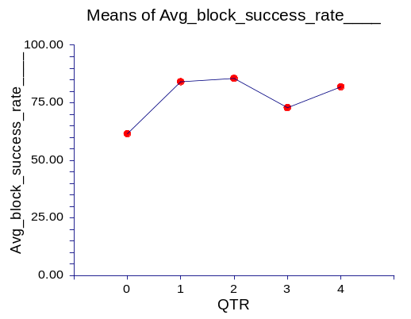

Tukey-Kramer Multiple-Comparison Test

Response: Avg_block_success_rate____
Term A: QTR

Alpha=0.050 Error Term=B(A) DF=27 MSE=3739.593 Critical Value=4.1305

Different From
Group Count Mean Groups
0 32 61.51563
3 31 72.83871
4 31 81.87096
1 31 84.09677
2 31 85.54839

Notes:
This report provides multiple comparison tests for all pairwise differences between
the means.

Repeated Measures ANOVA Report
Page/Date/Time 7 8/1/2014 1:24:03 PM
Database C:\Users\emariano\Desktop\FAER Analysis\FAER survey data.S0
Response Number_of_inadvertent_vascular_punture_w_o_injection____

Expected Mean Squares Section
Source Term Denominator Expected
Term DF Fixed? Term Mean Square
A: QTR 4 Yes B(A) S+sB+bsA
B(A): SUBJ 26 No S(AB) S+sB
S(AB) 123 No S
Note: Expected Mean Squares are for the balanced cell-frequency case.

Analysis of Variance Table
Source Sum of Mean Prob Power
Term DF Squares Square F-Ratio Level (Alpha=0.05)
A: QTR 4 86.57607 21.64402 1.20 0.333005 0.322836
B(A): SUBJ 26 467.5473 17.98259 0.93 0.570915
S 123 2386 19.39837
Total (Adjusted) 153 2940.123
Total 154
* Term significant at alpha = 0.05

Probability Levels for F-Tests with Geisser-Greenhouse Adjustments
Lower Geisser Huynh
Bound Greenhouse Feldt
Regular Epsilon Epsilon Epsilon
Source Prob Prob Prob Prob
Term DF F-Ratio Level Level Level Level
A: QTR 4 1.20 0.333005
B(A): SUBJ 26 0.93 0.570915
S 123

Power Values for F-Tests with Geisser-Greenhouse Adjustments Section
Lower Geisser Huynh
Bound Greenhouse Feldt
Regular Epsilon Epsilon Epsilon
Source Power Power Power Power
Term DF F-Ratio (Alpha=0.05) (Alpha=0.05) (Alpha=0.05) (Alpha=0.05)
A: QTR 4 1.20 0.322836
B(A): SUBJ 26 0.93 0.739897
S 123

Note: Mauchly's statistic actually tests the more restrictive assumption that the pooled covariance matrix
has compound symmetry.

Repeated Measures ANOVA Report
Page/Date/Time 8 8/1/2014 1:24:03 PM
Database C:\Users\emariano\Desktop\FAER Analysis\FAER survey data.S0
Response Number_of_inadvertent_vascular_punture_w_o_injection____

Means and Standard Error Section
Standard
Term Count Mean Error
All 154 0.7582796
A: QTR
0 30 1.533333 0.774222
1 31 1.806452 0.7616321
2 31 9.677419E-02 0.7616321
3 31 0.1935484 0.7616321
4 31 0.1612903 0.7616321

Plots Section

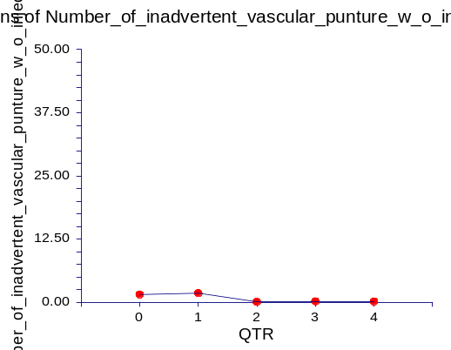

Tukey-Kramer Multiple-Comparison Test

Response: Number_of_inadvertent_vascular_punture_w_o_injection____
Term A: QTR

Alpha=0.050 Error Term=B(A) DF=26 MSE=17.98259 Critical Value=4.1415

Different From
Group Count Mean Groups
2 31 9.677419E-02
4 31 0.1612903
3 31 0.1935484
0 30 1.533333
1 31 1.806452

Notes:
This report provides multiple comparison tests for all pairwise differences between
the means.

Repeated Measures ANOVA Report
Page/Date/Time 9 8/1/2014 1:24:03 PM
Database C:\Users\emariano\Desktop\FAER Analysis\FAER survey data.S0
Response Number_of__intravascular_injections_resulting_in_seizures_or_cardiac_arrest____

Expected Mean Squares Section
Source Term Denominator Expected
Term DF Fixed? Term Mean Square
A: QTR 4 Yes B(A) S+sB+bsA
B(A): SUBJ 27 No S(AB) S+sB
S(AB) 124 No S
Note: Expected Mean Squares are for the balanced cell-frequency case.

Analysis of Variance Table
Source Sum of Mean Prob Power
Term DF Squares Square F-Ratio Level (Alpha=0.05)
A: QTR 4 0.6774452 0.1693613 1.01 0.417985 0.275951
B(A): SUBJ 27 4.512299 0.1671222 0.93 0.575861
S 124 22.4 0.1806452
Total (Adjusted) 155 27.58974
Total 156
* Term significant at alpha = 0.05

Probability Levels for F-Tests with Geisser-Greenhouse Adjustments
Lower Geisser Huynh
Bound Greenhouse Feldt
Regular Epsilon Epsilon Epsilon
Source Prob Prob Prob Prob
Term DF F-Ratio Level Level Level Level
A: QTR 4 1.01 0.417985
B(A): SUBJ 27 0.93 0.575861
S 124

Power Values for F-Tests with Geisser-Greenhouse Adjustments Section
Lower Geisser Huynh
Bound Greenhouse Feldt
Regular Epsilon Epsilon Epsilon
Source Power Power Power Power
Term DF F-Ratio (Alpha=0.05) (Alpha=0.05) (Alpha=0.05) (Alpha=0.05)
A: QTR 4 1.01 0.275951
B(A): SUBJ 27 0.93 0.749946
S 124

Note: Mauchly's statistic actually tests the more restrictive assumption that the pooled covariance matrix
has compound symmetry.

Repeated Measures ANOVA Report
Page/Date/Time 10 8/1/2014 1:24:03 PM
Database C:\Users\emariano\Desktop\FAER Analysis\FAER survey data.S0
Response Number_of__intravascular_injections_resulting_in_seizures_or_cardiac_arrest____

Means and Standard Error Section
Standard
Term Count Mean Error
All 156 5.100806E-02
A: QTR
0 32 0.09375 7.226733E-02
1 31 2.775558E-17 7.342368E-02
2 31 4.163336E-17 7.342368E-02
3 31 0.1612903 7.342368E-02
4 31 2.775558E-17 7.342368E-02

Plots Section

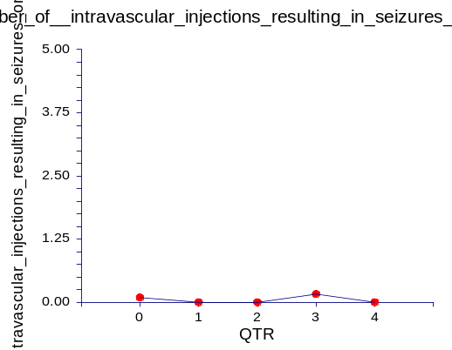

Tukey-Kramer Multiple-Comparison Test

Response: Number_of__intravascular_injections_resulting_in_seizures_or_cardiac_arrest____
Term A: QTR

Alpha=0.050 Error Term=B(A) DF=27 MSE=0.1671222 Critical Value=4.1305

Different From
Group Count Mean Groups
4 31 2.775558E-17
1 31 2.775558E-17
2 31 4.163336E-17
0 32 0.09375
3 31 0.1612903

Notes:
This report provides multiple comparison tests for all pairwise differences between
the means.

